Shinrl1 Bex

Joins and Subqueries

This is a checkpoint worth 5% Due 22nd August, push your work to Git (Lab or Hub) by 5pm.

For the following exercises, please use the database shown below (this is the Microsoft “Pubs” database). Familiarise yourself with the database diagram, then write the indicated queries. Please read the instructions for each group of queries carefully.

You can find the scripts to create and populate the tables on the I: drive.

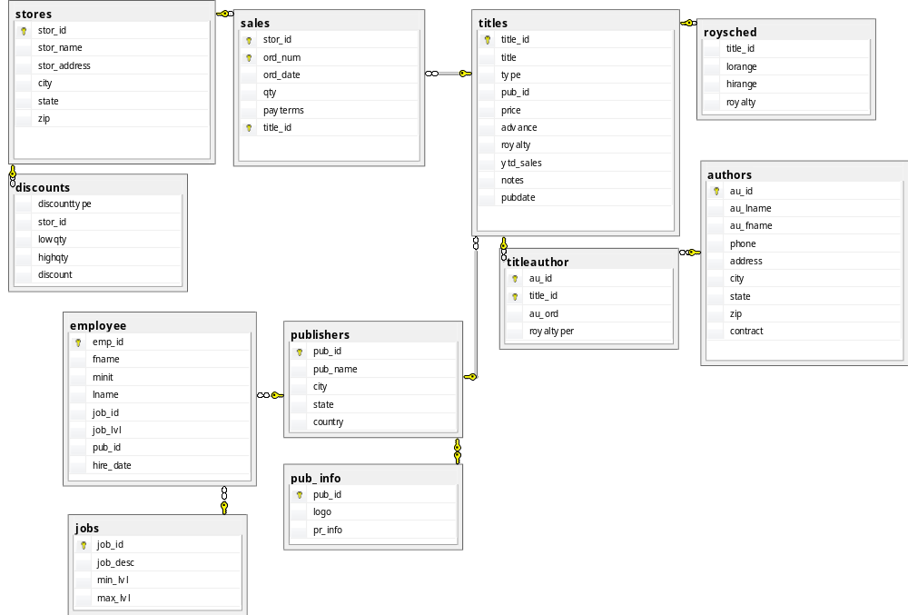

These queries can be written using joins or subqueries, please make sure you use a mixture of both.

- List the titles and prices of all books that have the cheapest price.
select title, price
from titles
where price = (select min(price) from titles);

- List all titles that have sold more than 40 copies at a single store.
select *
from titles
join sales on titles.title_id = sales.title_id
where qty > 40;
- List all authors who have not published any books.
select * from authors
full outer join titleauthor on authors.au_id = titleauthor.au_id
where title_id is null;
- List all the publishers who have published any business books.
select distinct pub_name
from publishers
join titles on publishers.pub_id = titles.pub_id
where type = 'business';
- List all authors who have published a “popular computing” book (these books have type = 'popular_comp' in the titles table).
select au_fname, au_lname
from authors
join titleauthor on authors.au_id = titleauthor.au_id
join titles on titleauthor.title_id = titles.title_id
where type = 'popular_comp';

- List all the cities where both an author (or authors) and a publisher (or publishers) are located.
select distinct city
from authors
where city in (select city from publishers);

- List all cities where an author, but no publisher, is located.
select distinct city
from authors
where NOT city in (select city from publishers);

- List all titles that have sold no copies.
select * from titles
full outer join sales on titles.title_id = sales.title_id
where qty is null;
- List the title and total sales of each book whose total sales is less than the average totals sales across all books.
First attempt:
select title, avgsales.totalsales from
(select qty, avg(qty) as totalsales, sales.title_id, title
from sales
join titles on sales.title_id = titles.title_id
group by qty, sales.title_id, title) avgsales

Actual attempt:
select titles.title, sum(qty)
from titles join sales on titles.title_id = sales.title_id
group by title having sum(qty) <
(select avg(sums.sumqty)
from
(select sum(qty) as sumqty from sales group by title_id) sums
) order by title

- List the publishers, and the number of books each has published, who are not located in California.
Select publishers.pub_name, count(titles.title_id)
from titles
join publishers on titles.pub_id = publishers.pub_id
where publishers.state != 'CA'
group by pub_name
- For each book, list the number of stores where it has been sold.
select title, count(titles.title_id)
from sales
join titles on sales.title_id = titles.title_id
join stores on stores.stor_id = sales.stor_id
group by title;

- For each book, list its title, the largest quantity of it sold at any one store, and the name of that store.
Select title,
stores.stor_name,
max(qty)
from sales
join titles on titles.title_id = sales.title_id
join stores on stores.stor_id = sales.stor_id
group by title, stores.stor_name
order by title asc

- Increase by two points the royalty rate for all books that have sold more than 30 copies total.

update titles
set royalty = (royalty + 2)
where title_id in (select title_id
from sales
where qty > 30);

Query 14: Challenge Problem. Think carefully about what set you need to produce to answer this question, and what tables you need to join to produce that set.
- List all types of books published by more than one publisher.

